**EX. NO. 4: USE GAE LAUNCHER TO LAUNCH THE WEB APPLICATIONS DATE:**

**AIM**: To launch GAE launcher to launch the web applications.

# PROCEDURE:

Deploying the app to App Engine

To upload the guest book app, run the following command from within the appengine-guestbook- python directory of your application where the app.yaml and index.yaml files are located:

# gcloud app deploy app.yaml index.yaml

**Optional flags:**

Include the --project flag to specify an alternate Cloud Console project ID to what you initialized a as the default in the gcloud tool.

Example: --project [YOUR_PROJECT_ID]

Include the -v flag to specify a version ID, otherwise one is generated for you. Example: -v [YOUR_VERSION_ID]

The Data store indexes might take some time to generate before your application is available. If the indexes are still in the process of being generated, you will receive a Need Index Error message when accessing your app. This is a transient error, so try a little later if at first you receive this error.

# Viewing your deployed application

To launch your browser and view the app at https://PROJECT_ID.REGION_ID.r.appspot.com, run the following command:

# gcloud app browse

**OUTPUT:**

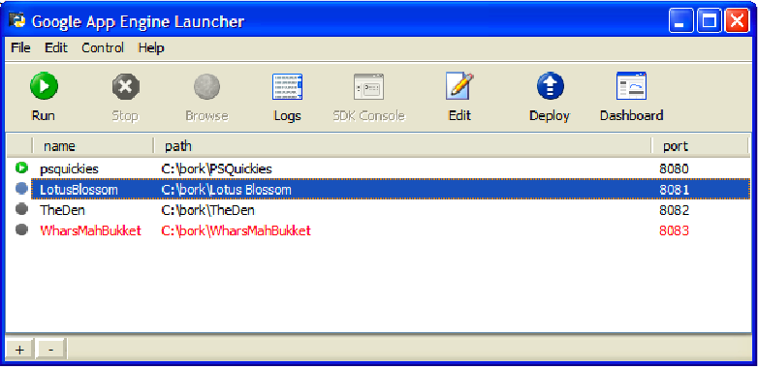

**RESULT:**